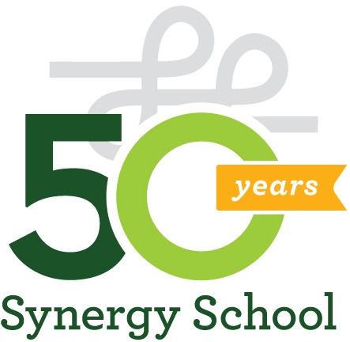

December 2023

Dear Sir or Madam:
I am writing on behalf of Synergy School in San Francisco, a progressive non-profit K-8 school located in San Francisco’s Mission District. Founded in 1973, our mission is to nurture the intellectual, creative, and emotional potential of every child in a community dedicated to diversity, inclusion, and social justice.

Synergy School is committed to being accessible and oﬀers financial aid assistance to more than one-third of our families each year. This is made possible by several fundraising events each year. Our largest parent run fundraiser is the Annual Auction.

The Solid Gold Annual Beneﬁt will be held on Saturday, March 9, 2024 at the SOMArts Cultural Center. Our goal is to raise over $135,000 to support tuition assistance and keep our tuition aﬀordable.

We hope you can again support our vibrant and economically diverse community by donating goods or services that could be auctioned to the highest bidder. Your tax-deductible donation will be auctioned to our entire community of parents, teachers, and friends. With our online auction at Bidding for Good and more than 275 people expected to attend our event, you are sure to receive great visibility.

I have included a donation form for you to fill in and return to Synergy School. All gifts are tax- deductible. Synergy School’s tax id number is 94-2245103.

Thank you for your support of the Synergy School fundraiser. Sincerely,
Kristy Troup

Kristy Troup
Synergy School Parent and Auction Chair

1387 Valencia Street San Francisco, CA 94110 www.synergyschool.org 415 567 6177

