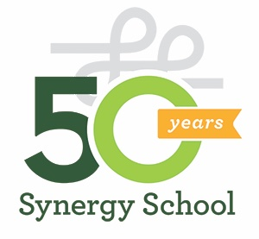

Synergy School
1387 Valencia Street
San Francisco, CA 94110
Phone: 415-567-6177

Dear

On behalf of Synergy School, I’m writing to thank you for your donation of___________ to the Synergy School Solid Gold 50th Anniversary Fundraiser on March 9, 2024.

Your generosity supports academic excellence, affordable tuition, diversity and financial aid for more than 30% of our families. The Auction fundraiser brings together our whole community for a fun evening and nets over $100,000 to help keep our school accessible for all students. Synergy’s tax ID is # 94-2245103.

Thank you for your generous support of Synergy School.

Sincerely,

Synergy School

